Practical Chinese Character Recognition using Computational Algorithms

The purpose of this project is to develop a practical method of writing Chinese characters that are handwritten on a writing tablet. In this project, I have developed a flexible character recognition engine with the following features:

* A modular character recognition engine which allows unlimited easy addition of new character recognition algorithms
* A database which stores the characteristics of each Chinese character as determined by the character recognition algorithms
* A method for loading the database via the input of characters through the character recognition engine
* Ability to quickly develop simple algorithms to recognize the most common characters.
* Ability to develop more sophisticated algorithms to handle more unusual characters
* Capability for human testing, feedback, and improvement of recognition accuracy

This book entails a written and typed history of the growth of ideas for the Chinese character finder project

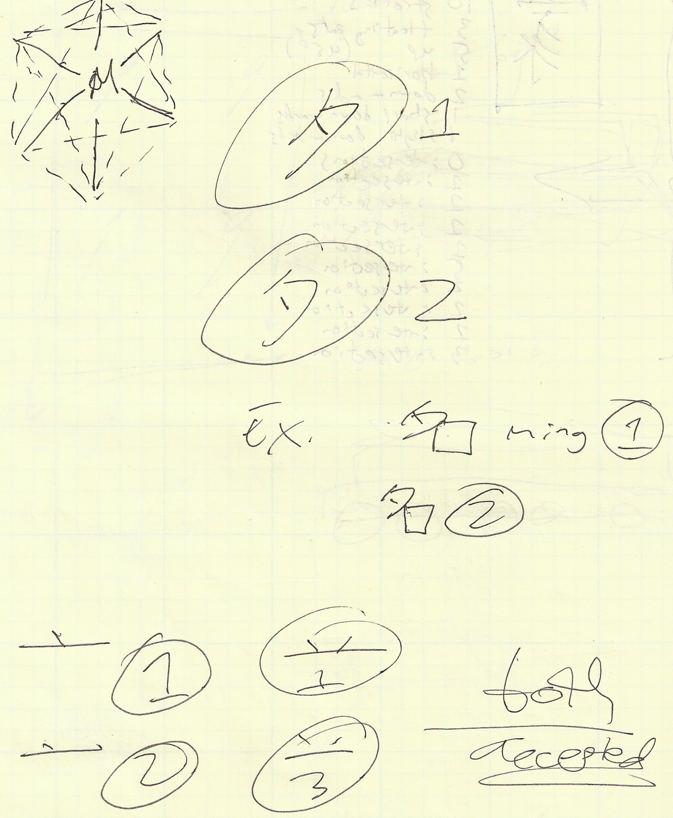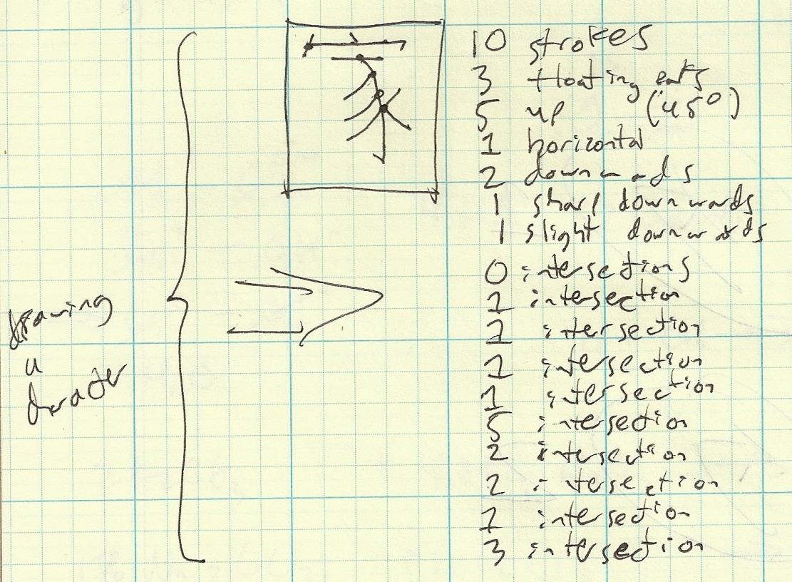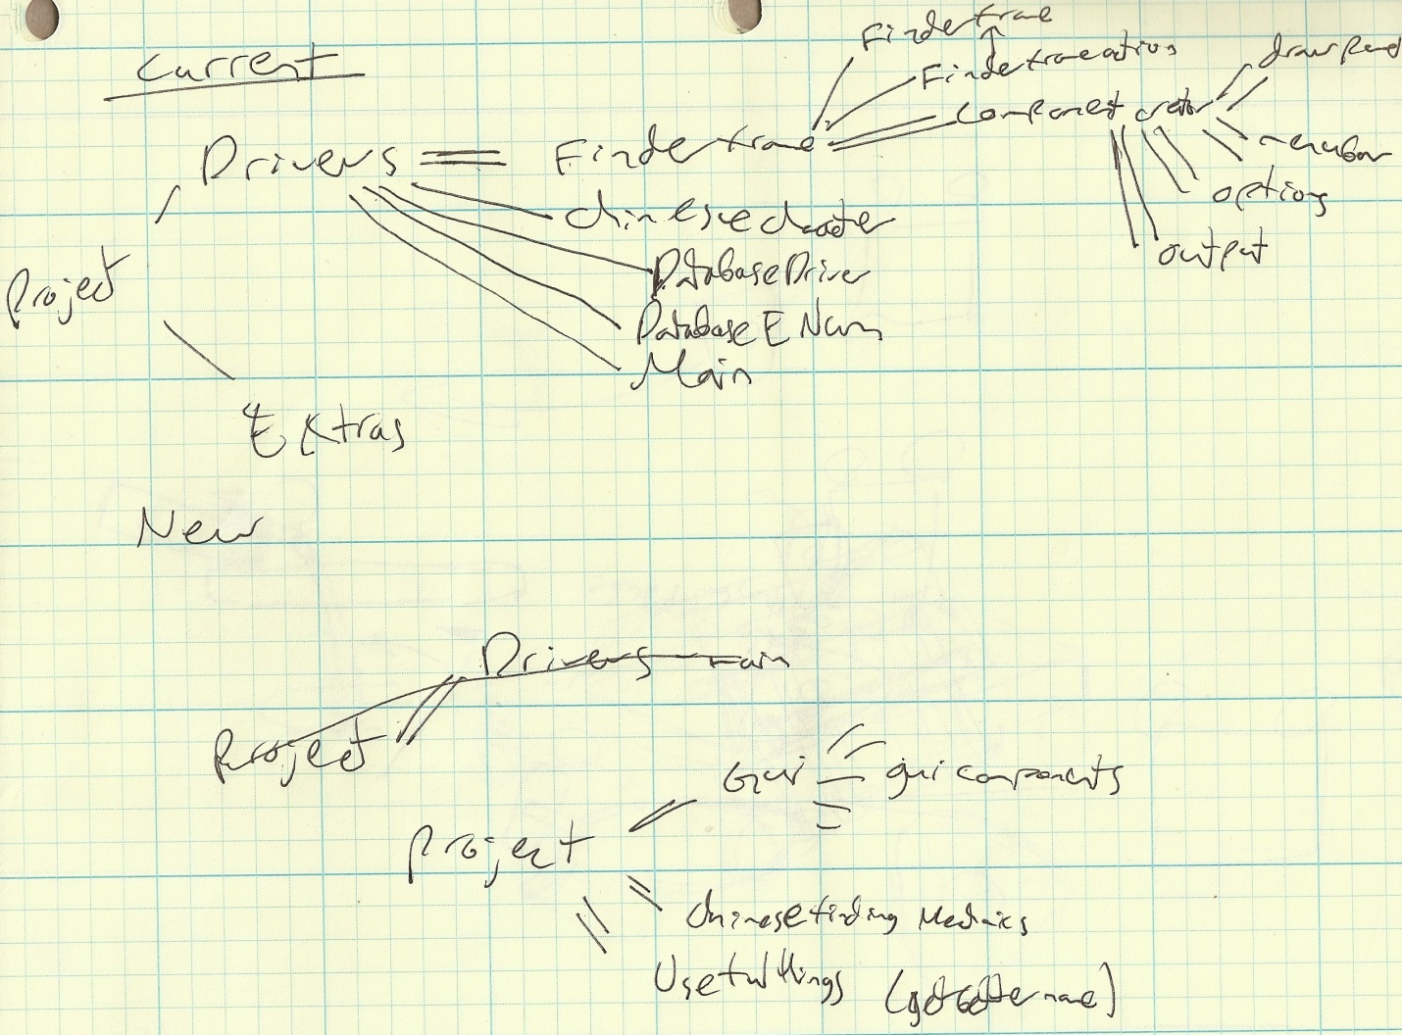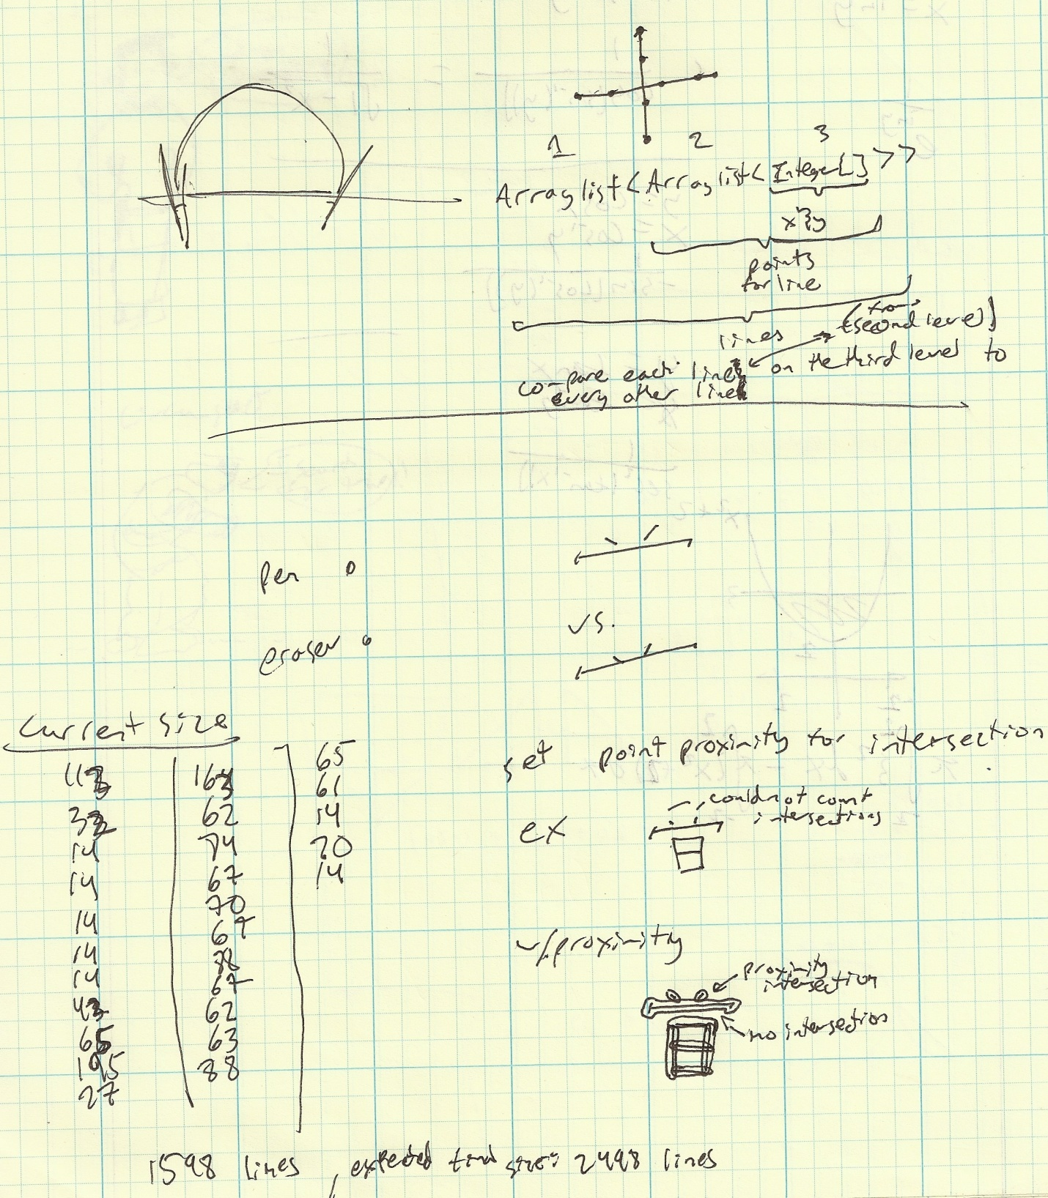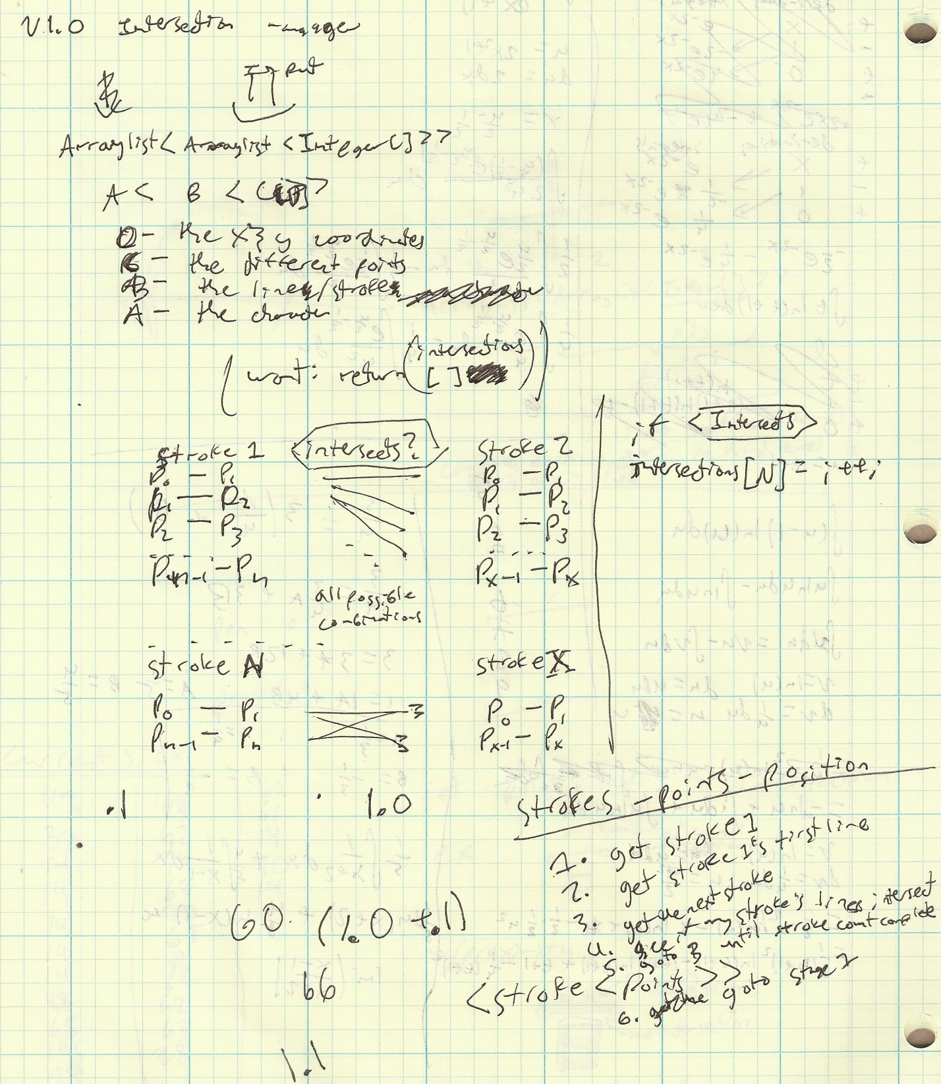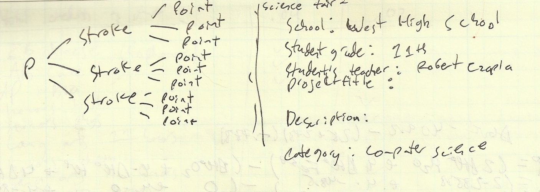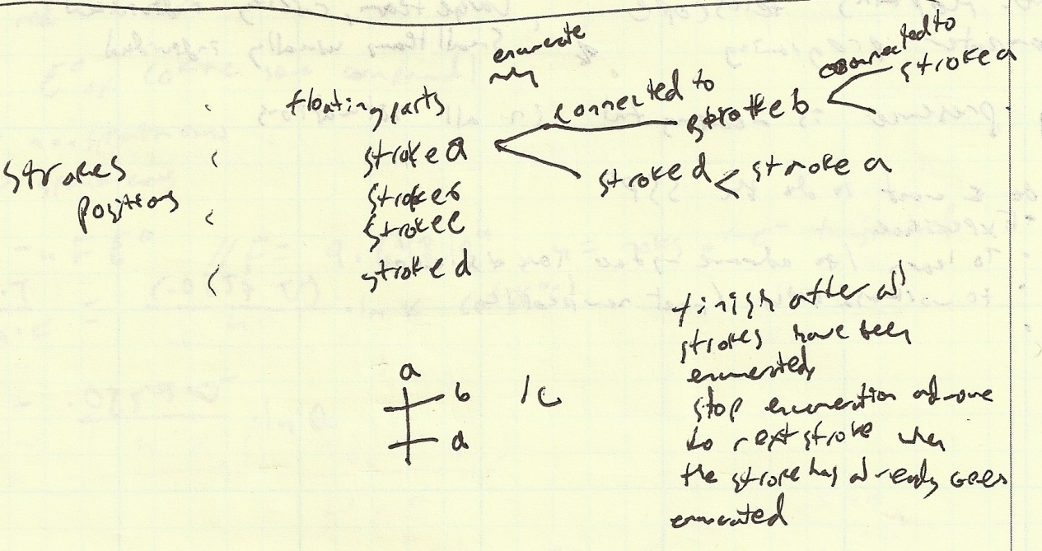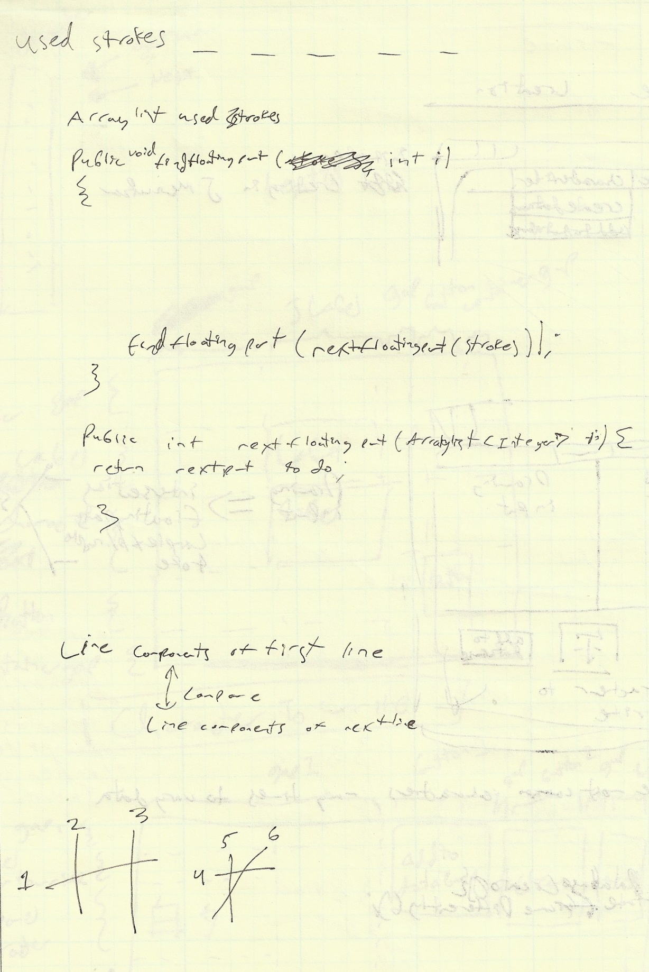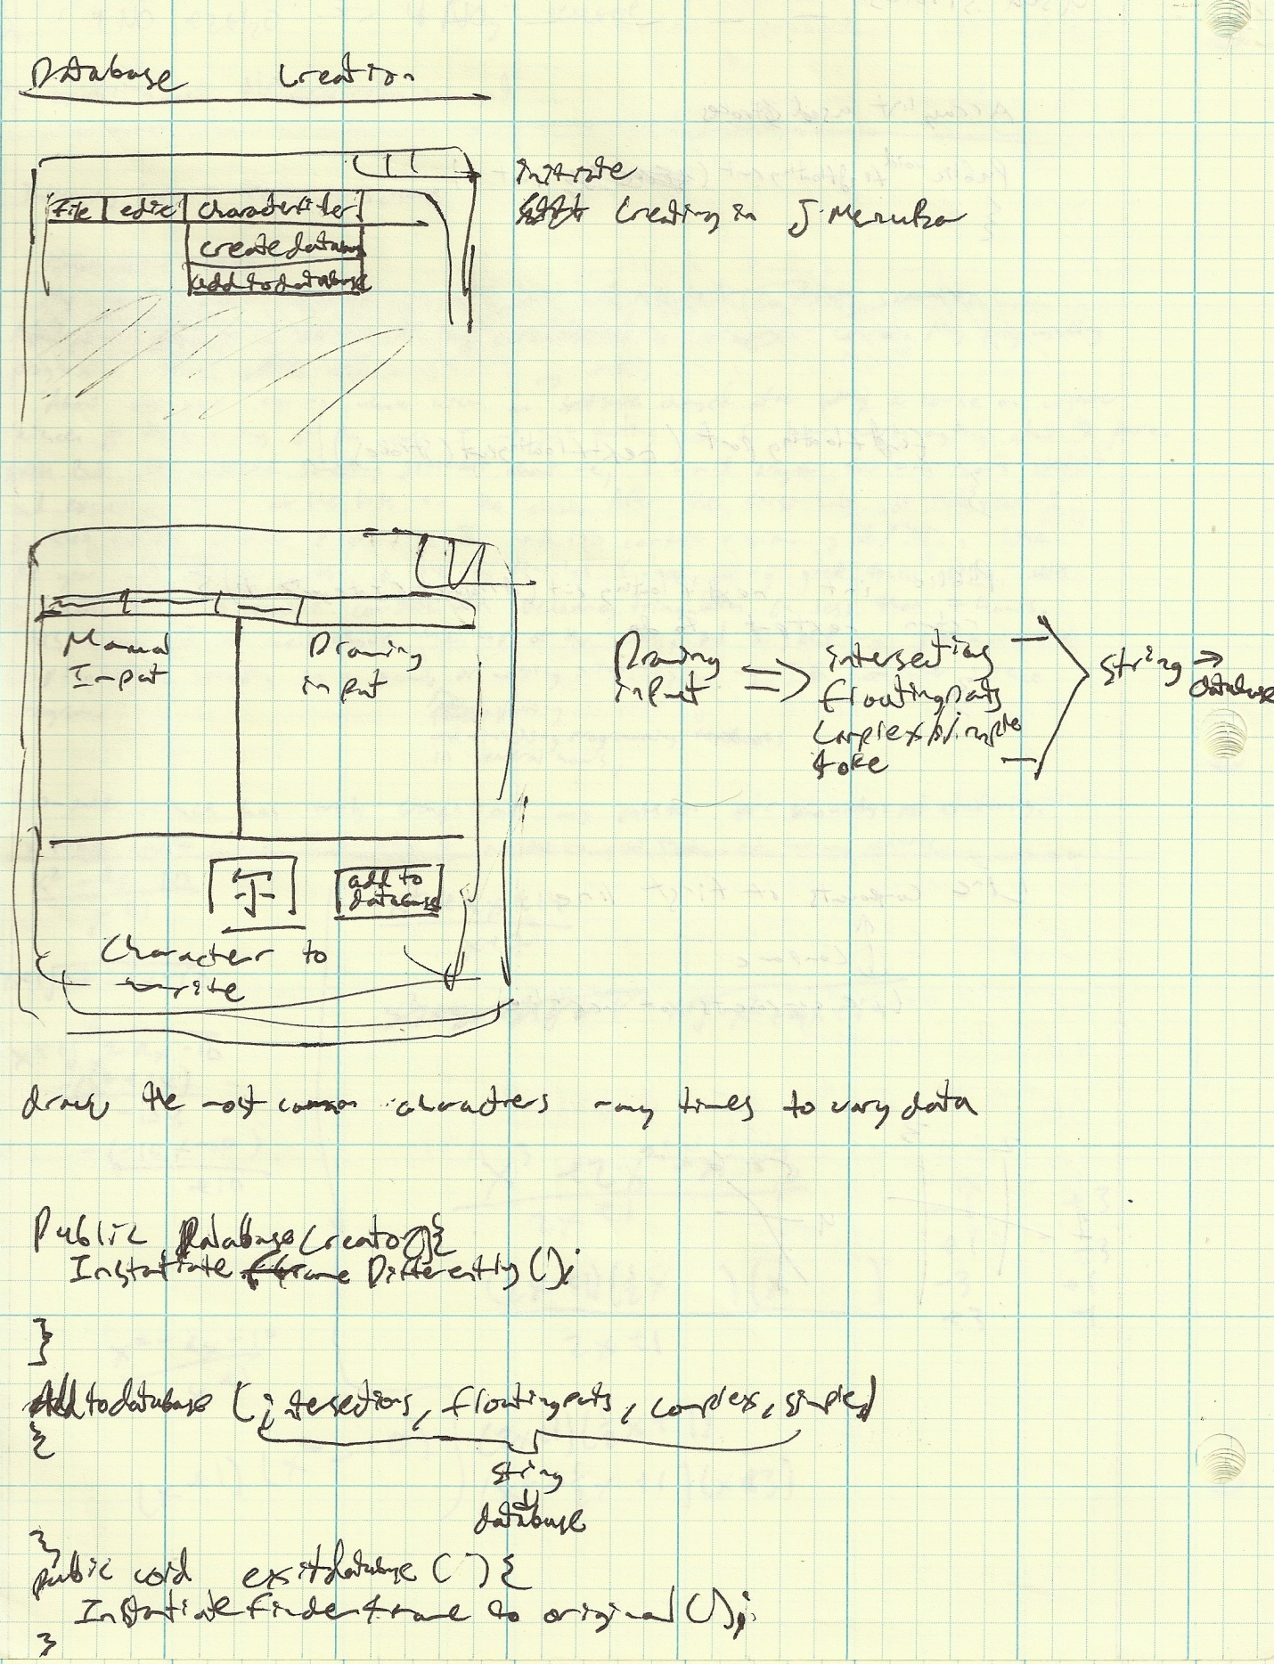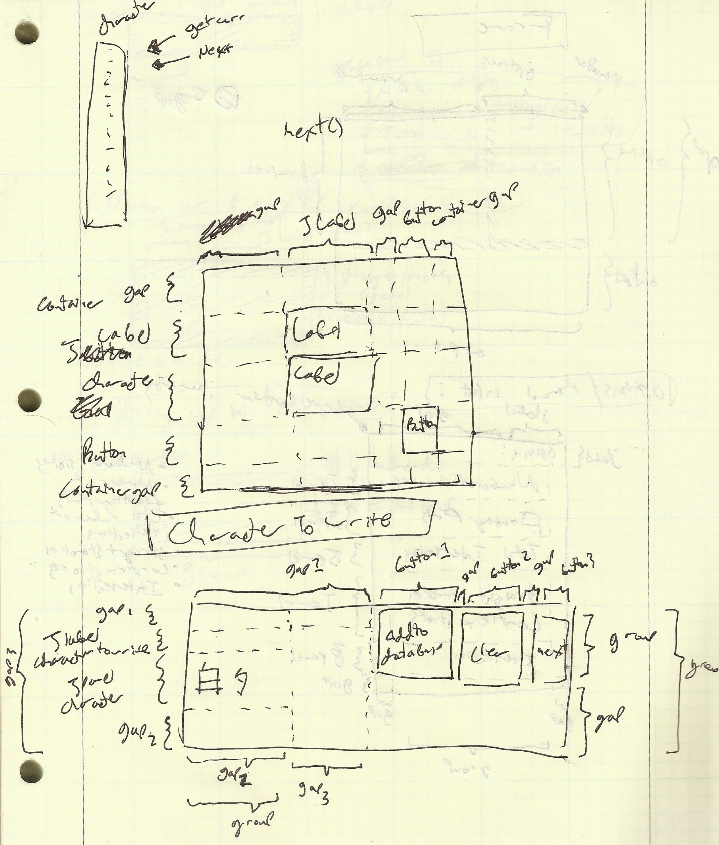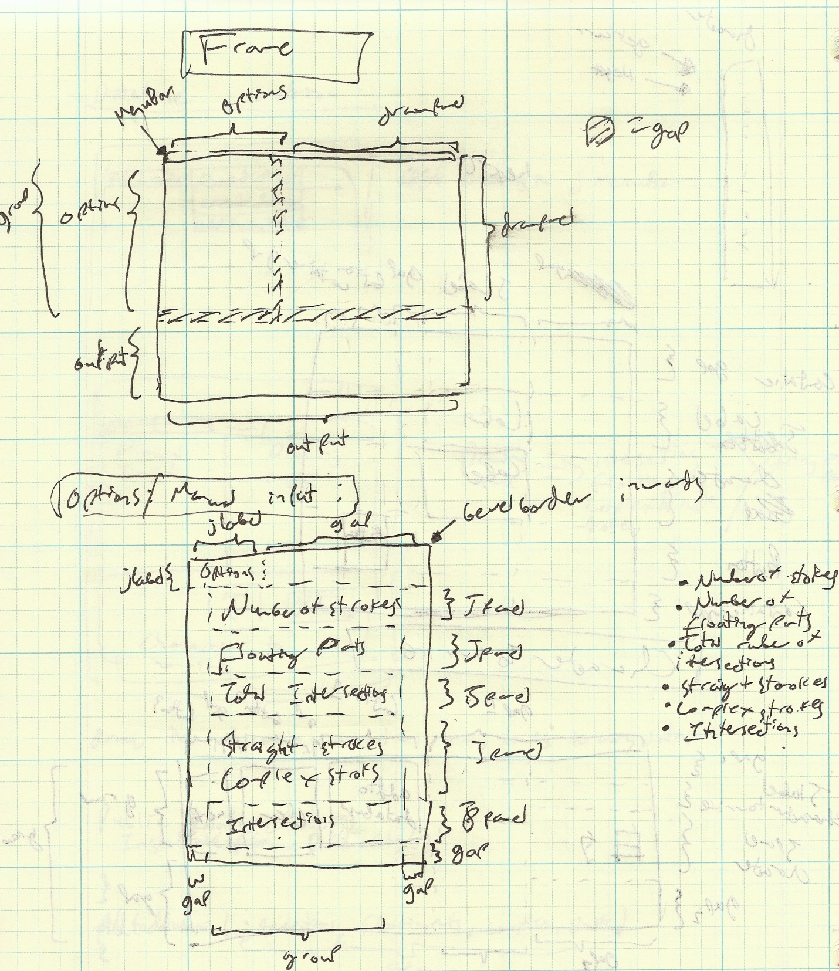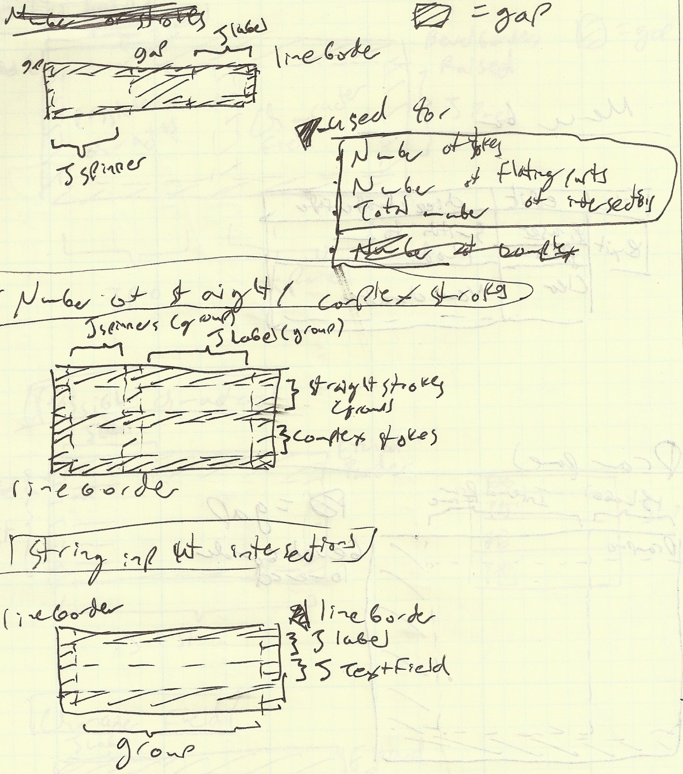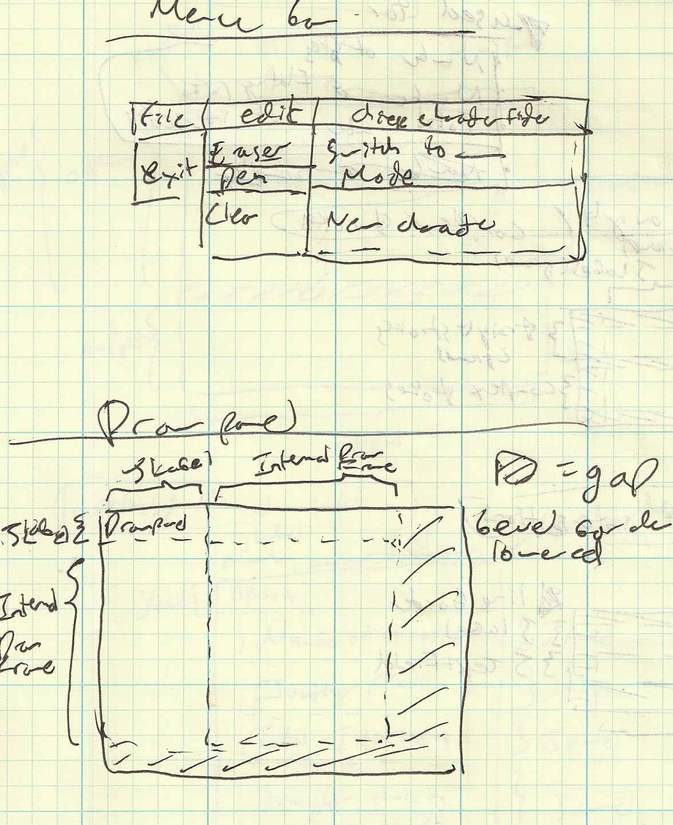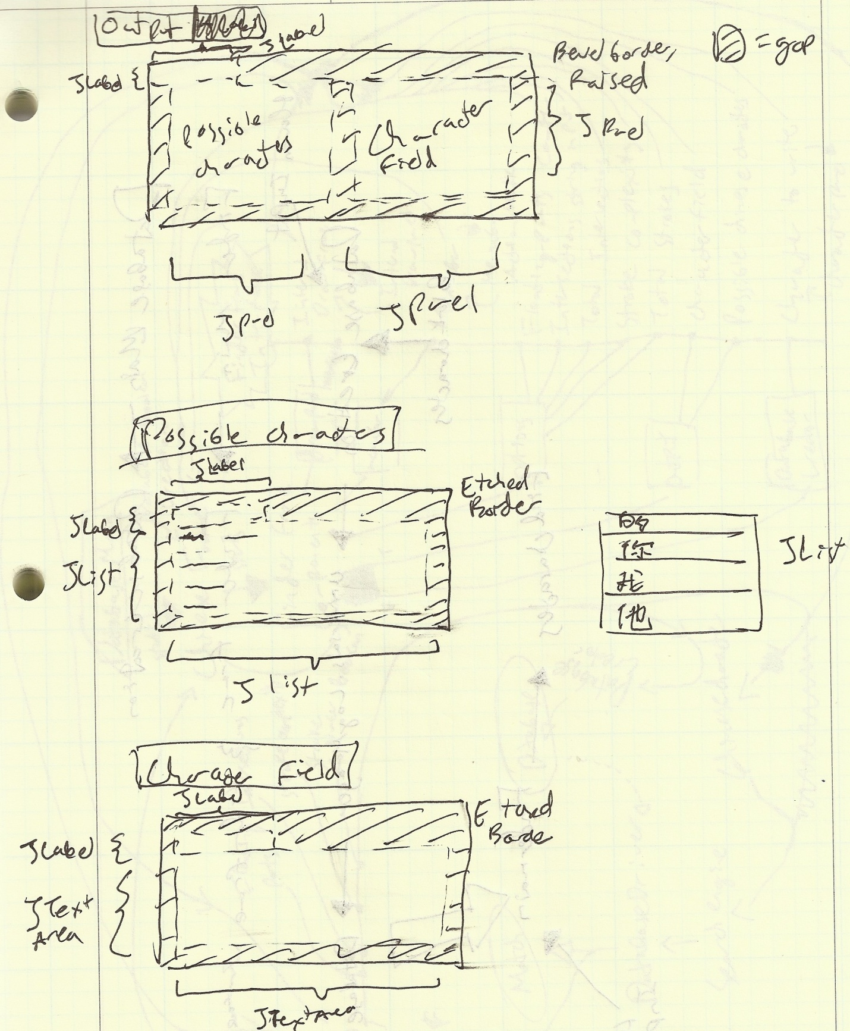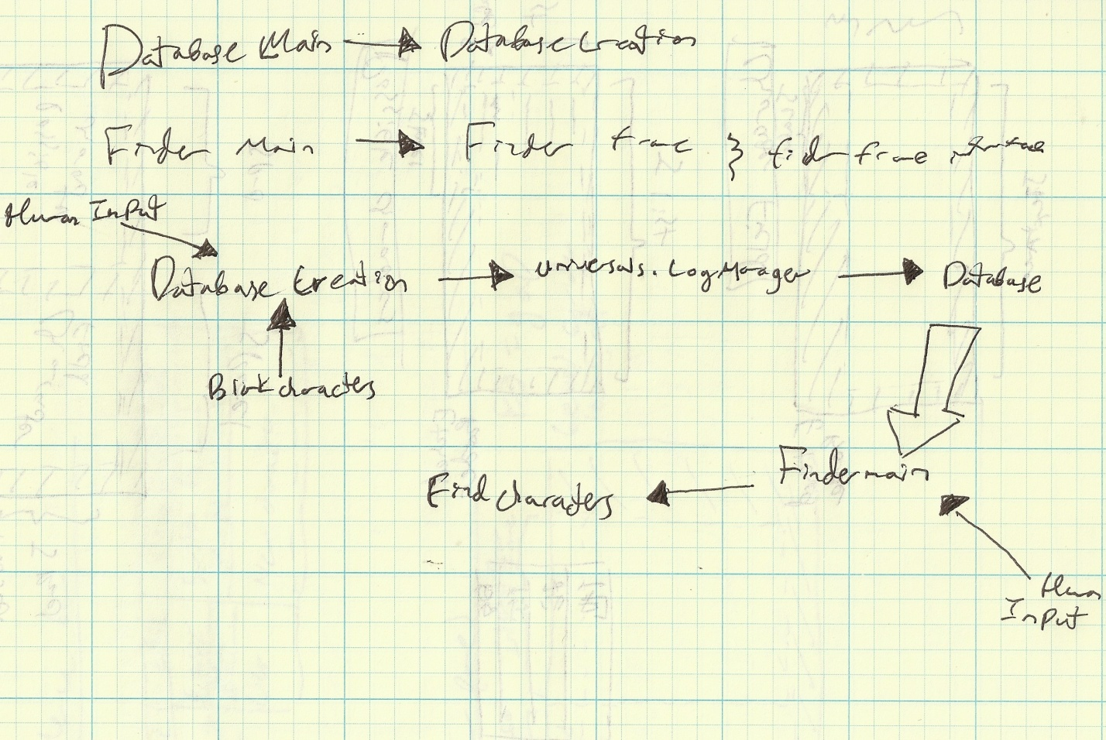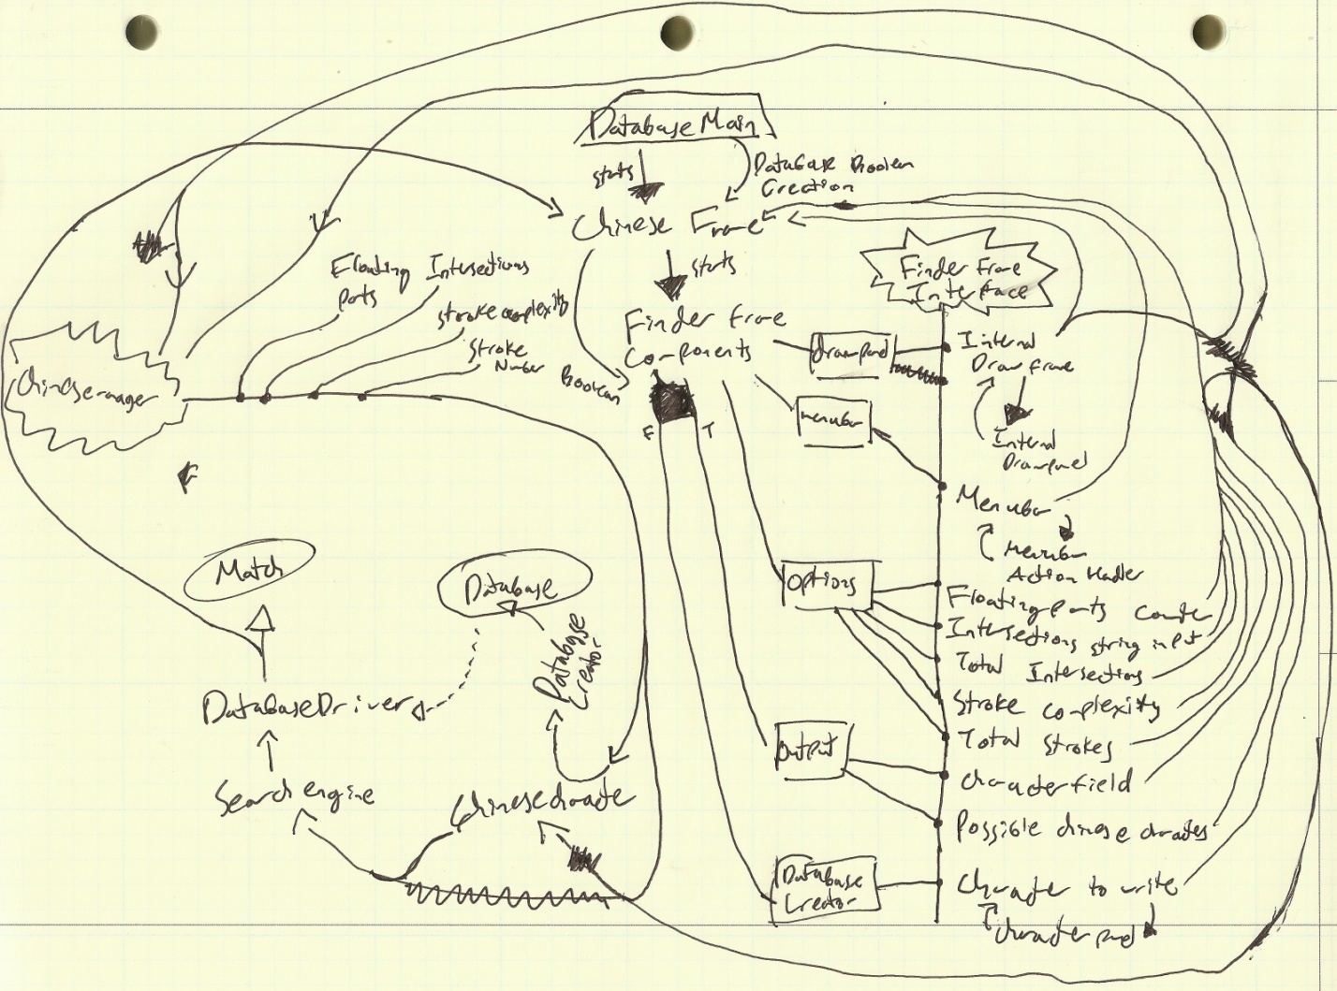

**Error handling:**

Peculiar errors: 1-9-2011-

run:

Exception in thread "AWT-EventQueue-0" java.lang.ExceptionInInitializerError

at drivers.FinderFrame.FinderFrame.initFrame(FinderFrame.java:83)

at drivers.FinderFrame.FinderFrame.<init>(FinderFrame.java:76)

at drivers.Main$1.run(Main.java:27)

at java.awt.event.InvocationEvent.dispatch(InvocationEvent.java:209)

at java.awt.EventQueue.dispatchEvent(EventQueue.java:597)

at java.awt.EventDispatchThread.pumpOneEventForFilters(EventDispatchThread.java:269)

at java.awt.EventDispatchThread.pumpEventsForFilter(EventDispatchThread.java:184)

at java.awt.EventDispatchThread.pumpEventsForHierarchy(EventDispatchThread.java:174)

at java.awt.EventDispatchThread.pumpEvents(EventDispatchThread.java:169)

at java.awt.EventDispatchThread.pumpEvents(EventDispatchThread.java:161)

at java.awt.EventDispatchThread.run(EventDispatchThread.java:122)

Caused by: java.lang.NullPointerException

at drivers.FinderFrame.componentCreator.menubar.MenuBar.<init>(MenuBar.java:30)

at drivers.FinderFrame.componentCreator.FinderFrameComponents.<clinit>(FinderFrameComponents.java:43)

... 11 more

BUILD SUCCESSFUL (total time: 1 second)

Could not initialize the main frame

1-9-2011

run:

Exception in thread "AWT-EventQueue-0" java.lang.StackOverflowError

at sun.awt.Win32GraphicsConfig.getBounds(Native Method)

at sun.awt.Win32GraphicsConfig.getBounds(Win32GraphicsConfig.java:215)

at java.awt.Window.init(Window.java:393)

at java.awt.Window.<init>(Window.java:432)

at java.awt.Frame.<init>(Frame.java:403)

at java.awt.Frame.<init>(Frame.java:368)

at javax.swing.JFrame.<init>(JFrame.java:163)

at drivers.FinderFrame.FinderFrame.<init>(FinderFrame.java:74)

at drivers.FinderFrame.componentCreator.FinderFrameComponents.<init>(FinderFrameComponents.java:33)

at drivers.FinderFrame.FinderFrame.initFrame(FinderFrame.java:83)

at drivers.FinderFrame.FinderFrame.<init>(FinderFrame.java:76)

at drivers.FinderFrame.componentCreator.FinderFrameComponents.<init>(FinderFrameComponents.java:33)

at drivers.FinderFrame.FinderFrame.initFrame(FinderFrame.java:83)

at drivers.FinderFrame.FinderFrame.<init>(FinderFrame.java:76)

Program stuck in infinite loop. Fixed by placing frame initialization in the Main.

1-9-2011

run:

Exception in thread "AWT-EventQueue-0" java.lang.IllegalArgumentException: Component must be non-null

at javax.swing.GroupLayout$ComponentSpring.<init>(GroupLayout.java:2878)

at javax.swing.GroupLayout$ComponentSpring.<init>(GroupLayout.java:2858)

at javax.swing.GroupLayout$Group.addComponent(GroupLayout.java:1490)

at javax.swing.GroupLayout$SequentialGroup.addComponent(GroupLayout.java:1771)

at drivers.FinderFrame.componentCreator.FinderFrameComponents.initOutputPanel(FinderFrameComponents.java:82)

at drivers.FinderFrame.componentCreator.FinderFrameComponents.initFinderFrameComponents(FinderFrameComponents.java:54)

at drivers.FinderFrame.FinderFrame.initFrame(FinderFrame.java:84)

at drivers.Main$1.run(Main.java:28)

at java.awt.event.InvocationEvent.dispatch(InvocationEvent.java:209)

at java.awt.EventQueue.dispatchEvent(EventQueue.java:597)

at java.awt.EventDispatchThread.pumpOneEventForFilters(EventDispatchThread.java:269)

at java.awt.EventDispatchThread.pumpEventsForFilter(EventDispatchThread.java:184)

at java.awt.EventDispatchThread.pumpEventsForHierarchy(EventDispatchThread.java:174)

at java.awt.EventDispatchThread.pumpEvents(EventDispatchThread.java:169)

at java.awt.EventDispatchThread.pumpEvents(EventDispatchThread.java:161)

at java.awt.EventDispatchThread.run(EventDispatchThread.java:122)

BUILD SUCCESSFUL (total time: 2 seconds)

Component returning null. Fixed by initializing component before called

1-9-2010

run:

Exception in thread "AWT-EventQueue-0" java.lang.NullPointerException

at drivers.FinderFrame.componentCreator.drawpanel.ChineseDrawFrame.paint(ChineseDrawFrame.java:104)

at javax.swing.JComponent.paintChildren(JComponent.java:864)

at javax.swing.JComponent.paint(JComponent.java:1038)

at javax.swing.JComponent.paintChildren(JComponent.java:864)

at javax.swing.JComponent.paint(JComponent.java:1038)

at javax.swing.JComponent.paintChildren(JComponent.java:864)

at javax.swing.JComponent.paint(JComponent.java:1038)

at javax.swing.JLayeredPane.paint(JLayeredPane.java:567)

at javax.swing.JComponent.paintChildren(JComponent.java:864)

at javax.swing.JComponent.paintToOffscreen(JComponent.java:5131)

at javax.swing.RepaintManager$PaintManager.paintDoubleBuffered(RepaintManager.java:1475)

at javax.swing.RepaintManager$PaintManager.paint(RepaintManager.java:1406)

at javax.swing.RepaintManager.paint(RepaintManager.java:1220)

at javax.swing.JComponent.paint(JComponent.java:1015)

at java.awt.GraphicsCallback$PaintCallback.run(GraphicsCallback.java:21)

at sun.awt.SunGraphicsCallback.runOneComponent(SunGraphicsCallback.java:60)

at sun.awt.SunGraphicsCallback.runComponents(SunGraphicsCallback.java:97)

at java.awt.Container.paint(Container.java:1780)

at javax.swing.RepaintManager.paintDirtyRegions(RepaintManager.java:814)

at javax.swing.RepaintManager.paintDirtyRegions(RepaintManager.java:714)

at javax.swing.RepaintManager.seqPaintDirtyRegions(RepaintManager.java:694)

at javax.swing.SystemEventQueueUtilities$ComponentWorkRequest.run(SystemEventQueueUtilities.java:128)

at java.awt.event.InvocationEvent.dispatch(InvocationEvent.java:209)

at java.awt.EventQueue.dispatchEvent(EventQueue.java:597)

at java.awt.EventDispatchThread.pumpOneEventForFilters(EventDispatchThread.java:269)

at java.awt.EventDispatchThread.pumpEventsForFilter(EventDispatchThread.java:184)

at java.awt.EventDispatchThread.pumpEventsForHierarchy(EventDispatchThread.java:174)

at java.awt.EventDispatchThread.pumpEvents(EventDispatchThread.java:169)

at java.awt.EventDispatchThread.pumpEvents(EventDispatchThread.java:161)

at java.awt.EventDispatchThread.run(EventDispatchThread.java:122)

Cannot paint out of Jpanel region. Fixed by filtering region which can be painted.

1-9-2011

run:

Exception in thread "Thread-2" java.lang.NullPointerException

at drivers.FinderFrame.componentCreator.drawpanel.ChineseDrawFrame.pointcheck(ChineseDrawFrame.java:139)

at drivers.FinderFrame.componentCreator.drawpanel.ChineseDrawFrame.run(ChineseDrawFrame.java:93)

at drivers.FinderFrame.componentCreator.drawpanel.ChineseDrawFrame.run(ChineseDrawFrame.java:106)

at drivers.FinderFrame.componentCreator.drawpanel.ChineseDrawFrame.run(ChineseDrawFrame.java:106)

thread continuously calls null while initialization. Fixed by initializing thread.

1-10-2011

run:

[1]

[1, 2]

[1, 2]

[1, 2, 3]

[, 3, ^0^1^1^1^1^1^1^4^2^1^, 8, 2]

Exception in thread "AWT-EventQueue-0" java.lang.NumberFormatException: For input string: "^0^1^1^1^1^1^1^4^2^1^"

[, 3, ^0^1^1^1^1^1^1^4^2^1^, 8, 2]

at java.lang.NumberFormatException.forInputString(NumberFormatException.java:48)

at java.lang.Integer.parseInt(Integer.java:449)

at java.lang.Integer.parseInt(Integer.java:499)

at drivers.DatabaseDriver.searchCharacter(DatabaseDriver.java:37)

at drivers.DatabaseDriver.searchCharacter(DatabaseDriver.java:19)

at drivers.FinderFrame.FinderFrame.searchForChineseCharacter(FinderFrame.java:141)

at drivers.FinderFrame.FinderFrameActionHandler.numberOfStraightStrokesCounterPropertyChange(FinderFrameActionHandler.java:48)

at drivers.FinderFrame.componentCreator.options.StraightAndComplexStrokes$1.propertyChange(StraightAndComplexStrokes.java:37)

at java.beans.PropertyChangeSupport.firePropertyChange(PropertyChangeSupport.java:339)

at java.beans.PropertyChangeSupport.firePropertyChange(PropertyChangeSupport.java:276)

at java.awt.Component.firePropertyChange(Component.java:8128)

at javax.swing.JComponent.putClientProperty(JComponent.java:4039)

at com.sun.java.swing.plaf.windows.AnimationController.putState(AnimationController.java:184)

at com.sun.java.swing.plaf.windows.AnimationController.triggerAnimation(AnimationController.java:102)

at com.sun.java.swing.plaf.windows.AnimationController.paintSkin(AnimationController.java:224)

at com.sun.java.swing.plaf.windows.XPStyle$Skin.paintSkin(XPStyle.java:585)

at com.sun.java.swing.plaf.windows.XPStyle$GlyphButton.paintComponent(XPStyle.java:717)

at javax.swing.JComponent.paint(JComponent.java:1029)

at javax.swing.JComponent.paintChildren(JComponent.java:864)

at javax.swing.JComponent.paint(JComponent.java:1038)

at javax.swing.JComponent.paintToOffscreen(JComponent.java:5124)

at javax.swing.RepaintManager$PaintManager.paintDoubleBuffered(RepaintManager.java:1475)

at javax.swing.RepaintManager$PaintManager.paint(RepaintManager.java:1406)

at javax.swing.RepaintManager.paint(RepaintManager.java:1220)

at javax.swing.JComponent._paintImmediately(JComponent.java:5072)

at javax.swing.JComponent.paintImmediately(JComponent.java:4882)

at javax.swing.RepaintManager.paintDirtyRegions(RepaintManager.java:803)

at javax.swing.RepaintManager.paintDirtyRegions(RepaintManager.java:714)

at javax.swing.RepaintManager.seqPaintDirtyRegions(RepaintManager.java:694)

at javax.swing.SystemEventQueueUtilities$ComponentWorkRequest.run(SystemEventQueueUtilities.java:128)

at java.awt.event.InvocationEvent.dispatch(InvocationEvent.java:209)

at java.awt.EventQueue.dispatchEvent(EventQueue.java:597)

at java.awt.EventDispatchThread.pumpOneEventForFilters(EventDispatchThread.java:269)

at java.awt.EventDispatchThread.pumpEventsForFilter(EventDispatchThread.java:184)

at java.awt.EventDispatchThread.pumpEventsForHierarchy(EventDispatchThread.java:174)

at java.awt.EventDispatchThread.pumpEvents(EventDispatchThread.java:169)

at java.awt.EventDispatchThread.pumpEvents(EventDispatchThread.java:161)

at java.awt.EventDispatchThread.run(EventDispatchThread.java:122)

1-10-2011

run:

Exception in thread "Thread-2" java.lang.StackOverflowError

at java.util.HashMap.put(HashMap.java:385)

at java.util.HashSet.add(HashSet.java:200)

at sun.awt.AWTAutoShutdown.notifyThreadBusy(AWTAutoShutdown.java:151)

at java.awt.EventQueue.postEvent(EventQueue.java:262)

at java.awt.EventQueue.postEventPrivate(EventQueue.java:202)

at java.awt.EventQueue.postEvent(EventQueue.java:175)

at javax.swing.SystemEventQueueUtilities.queueComponentWorkRequest(SystemEventQueueUtilities.java:169)

at javax.swing.SystemEventQueueUtilities.queueComponentWorkRequest(SystemEventQueueUtilities.java:142)

at javax.swing.RepaintManager.addDirtyRegion0(RepaintManager.java:443)

at javax.swing.RepaintManager.addDirtyRegion(RepaintManager.java:465)

at javax.swing.JComponent.repaint(JComponent.java:4734)

at java.awt.Component.repaint(Component.java:3081)

at drivers.FinderFrame.componentCreator.drawpanel.ChineseDrawFrame.run(ChineseDrawFrame.java:96)

at drivers.FinderFrame.componentCreator.drawpanel.ChineseDrawFrame.run(ChineseDrawFrame.java:106)

at drivers.FinderFrame.componentCreator.drawpanel.ChineseDrawFrame.run(ChineseDrawFrame.java:106)

at drivers.FinderFrame.componentCreator.drawpanel.ChineseDrawFrame.run(ChineseDrawFrame.java:106)

at drivers.FinderFrame.componentCreator.drawpanel.ChineseDrawFrame.run(ChineseDrawFrame.java:106)

12-13-2011

run:

[0]

[1, 1]

Exception in thread "AWT-EventQueue-0" java.lang.IndexOutOfBoundsException: Index: 1, Size: 1

at java.util.ArrayList.RangeCheck(ArrayList.java:547)

at java.util.ArrayList.get(ArrayList.java:322)

at universals.CreatedCharacter.erase(CreatedCharacter.java:26)

at gui.mainframe.componentCreator.drawpanel.InternalDrawFrame.mouseReleased(InternalDrawFrame.java:160)

at java.awt.AWTEventMulticaster.mouseReleased(AWTEventMulticaster.java:273)

at java.awt.Component.processMouseEvent(Component.java:6263)

at javax.swing.JComponent.processMouseEvent(JComponent.java:3267)

at java.awt.Component.processEvent(Component.java:6028)

at java.awt.Container.processEvent(Container.java:2041)

at java.awt.Component.dispatchEventImpl(Component.java:4630)

at java.awt.Container.dispatchEventImpl(Container.java:2099)

at java.awt.Component.dispatchEvent(Component.java:4460)

at java.awt.LightweightDispatcher.retargetMouseEvent(Container.java:4574)

at java.awt.LightweightDispatcher.processMouseEvent(Container.java:4238)

at java.awt.LightweightDispatcher.dispatchEvent(Container.java:4168)

at java.awt.Container.dispatchEventImpl(Container.java:2085)

at java.awt.Window.dispatchEventImpl(Window.java:2475)

at java.awt.Component.dispatchEvent(Component.java:4460)

at java.awt.EventQueue.dispatchEvent(EventQueue.java:599)

at java.awt.EventDispatchThread.pumpOneEventForFilters(EventDispatchThread.java:269)

at java.awt.EventDispatchThread.pumpEventsForFilter(EventDispatchThread.java:184)

at java.awt.EventDispatchThread.pumpEventsForHierarchy(EventDispatchThread.java:174)

at java.awt.EventDispatchThread.pumpEvents(EventDispatchThread.java:169)

at java.awt.EventDispatchThread.pumpEvents(EventDispatchThread.java:161)

at java.awt.EventDispatchThread.run(EventDispatchThread.java:122)

BUILD SUCCESSFUL (total time: 9 seconds)

2-6-2011

A problem where an ArrayList holding the line lengths would not be able to retain previous parts of the ArrayList

V1.8

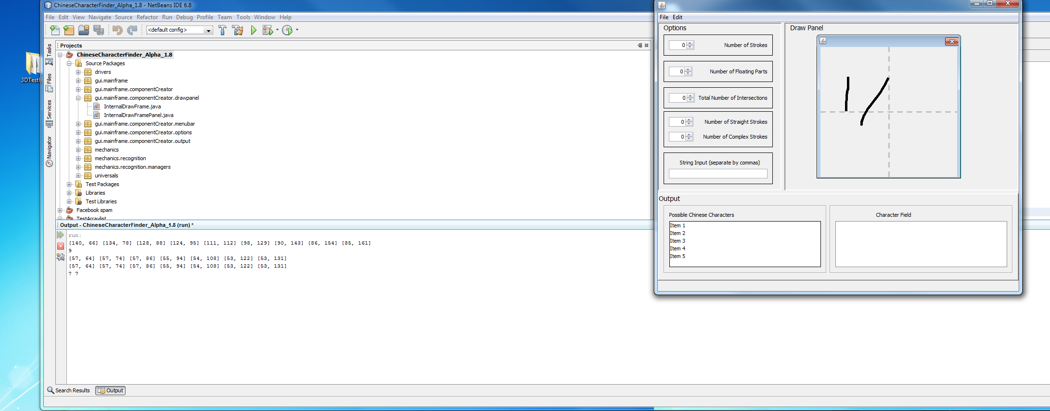

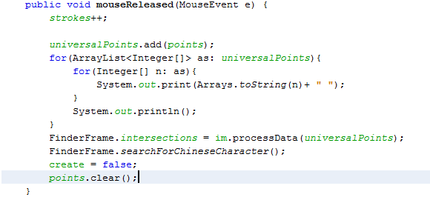

Says that the two strokes are the same

Error here, clearing the points’ size makes the Array Size constant

Original code when mouse is released

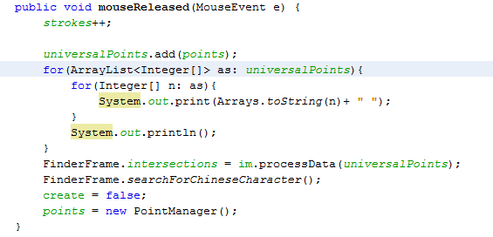

Fix by re-initialization of the ArrayList

1-9-2010

Problem painting directly onto a InternalDrawFrame. Because InternalFrames are pretty “HURR DURR,” I eventually used a JPanel to draw everything

VALPHA 1.0

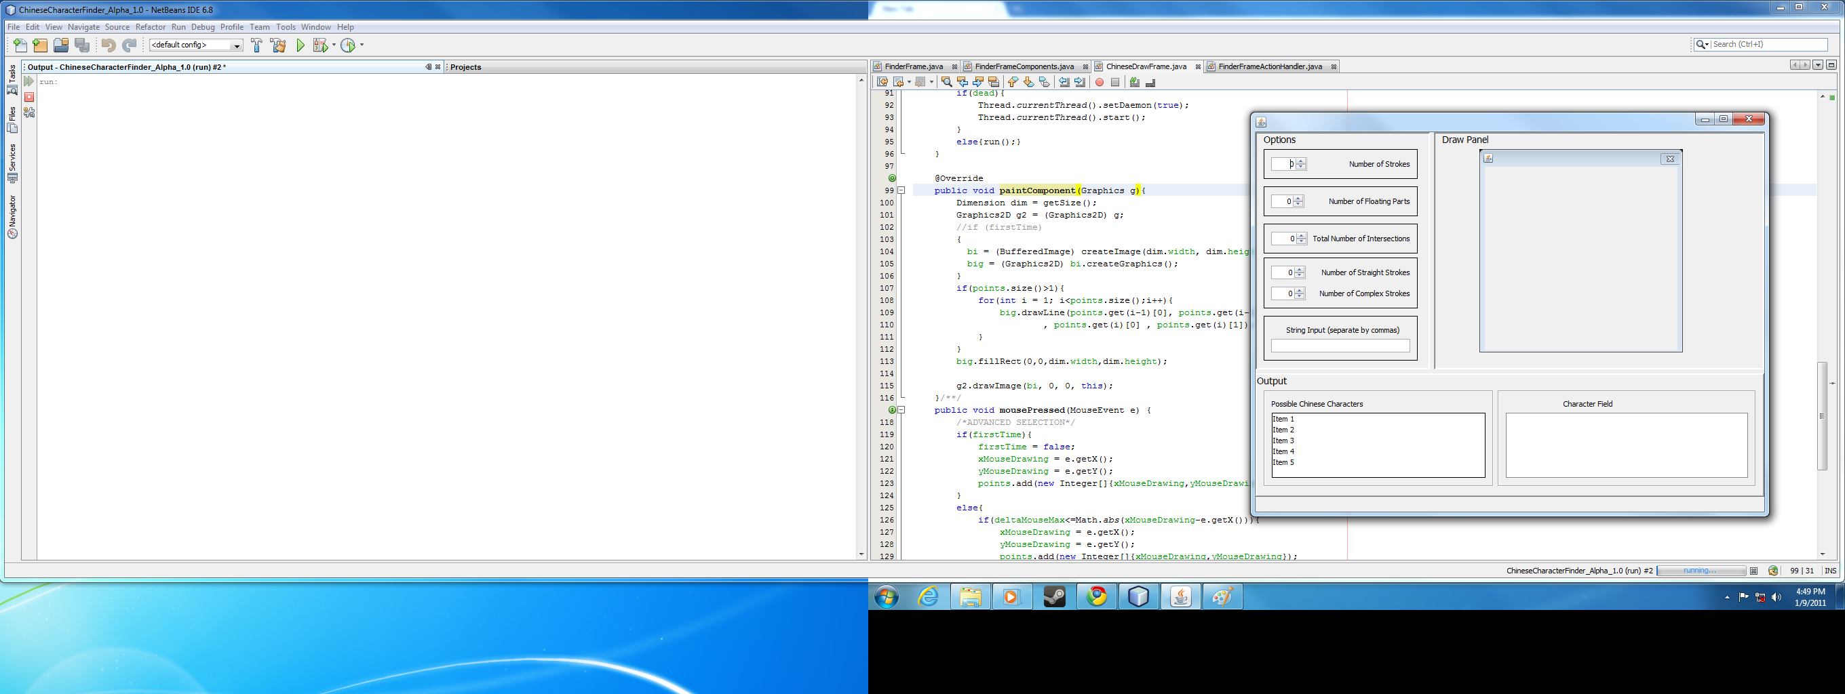

Paints behind if drawn after

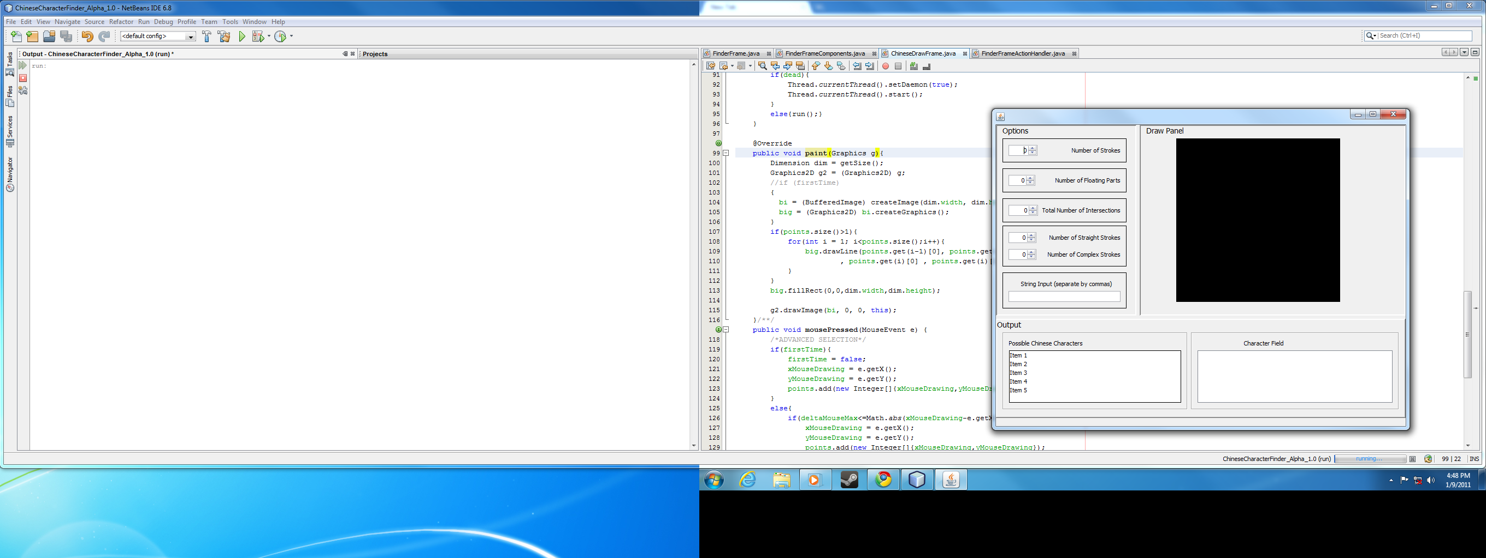

Paints in front if drawn later

2-20-2011

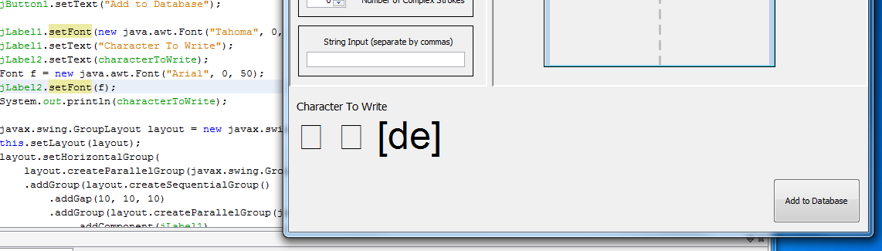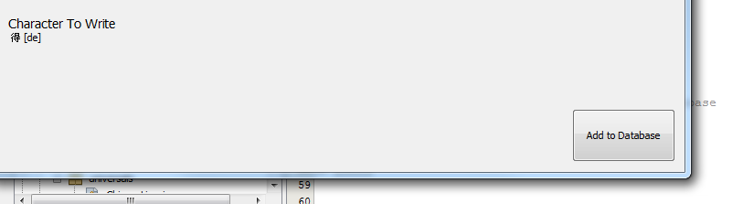Problem that the font for the new Database Creator would not show up unless if it were the default font size (i.e. no new Font with the size of 50). Changed font sized would show up as boxes. Fixed by drawing the character to buffered image in a JPanel, then using the BufferedImage for rescaling.

**Versions**

VERSION # ALPHA 0.25

Features a non-functional gui shell

gui lumped together in one giagantic class (will change)

gui too gigantic (will change)

internal draw panel does not work

Database driver is broken - does not retrieve information properly

only four classes, one package

GUI-

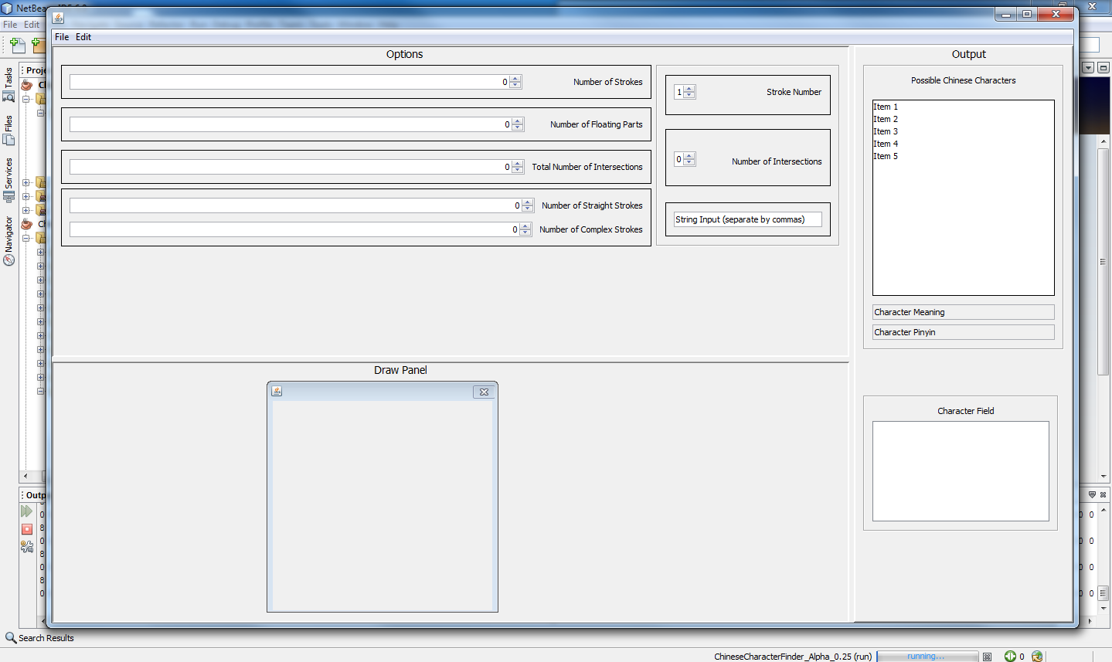

Output - 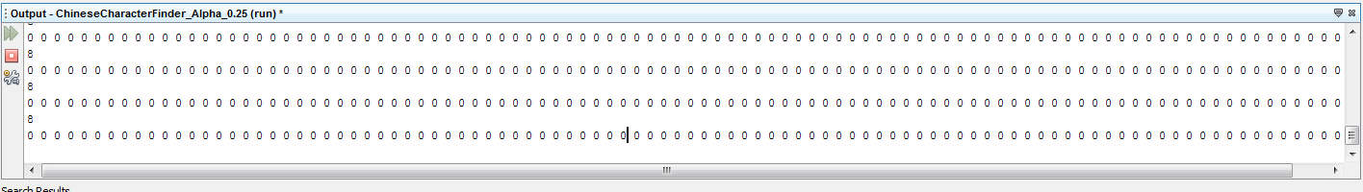

Continuous spewing out of 0’s the values in the options

VERSION # ALPHA 0.5

Not able to draw in the drawpanel

slightly more functional gui shell

gui shell revised- smaller, more compact

just uses a string input instead of intersection number, intersection value in V.25

Database not truly functional: attemt database enum (not filled)

interface created between all of the frame components

Basic Layout:

FinderFrame |→ FinderFrameComponents |→ Packages... |→ Components...

|→ FinderframeInterface |→ Packages... |→ Components...

↓ ↓

_________________________________________________________________

FinderFrameActionHandler

also various experimentation in database creation.

Thanks to http://www.zein.se/patrick/3000char.html for using their sorted database

See Project: "ChineseMakeDictionary" for the version used to convert data from website to

more usable information

Only a few characters are completely filled out.

VERSION # ALPHA 1.0

Remedial drawing capabilities in the drawpanel

Menubar does not show up (unknown currently)

Added on extras (extras package), "TimeAreAChanging" class (Calls the current time)

and the Logger class

both have basic functionality.

put frame and its components in the gui package

added on exception logging, added on problem solving screenshots and outputs of data in the "exception" folder

recognition of characters via manual input

VERSION # ALPHA 1.5

Not much different compared to V1.0

changed package "extras" to "universals"

Decided not to use an enum for the database

Improved functionality